Sea turtle sensitive area overlay code

Application

This code applies to development:-

- subject to the Sea turtle sensitive area in the Coastal protection overlay shown on the overlay maps contained within Schedule 2 (Mapping); and

- identified as requiring assessment against the Sea turtle sensitive area overlay code by the tables of assessment in Part 5 (Tables of assessment).

Purpose and overall outcomes

- The purpose of the Sea turtle sensitive area overlay code is to ensure that development does not create harm to sea turtle nesting and sea turtle activity by avoiding adverse impacts generated from development, including from artificial lighting.

- The purpose of the code will be achieved through the following overall outcomes:-

- development avoids artificial lighting that is directly visible from the beach or the ocean;

- development avoids artificial lighting that contributes to sky glow within the Sea turtle sensitive area; and

- development is compatible with the existing and intended scale, density and character of the zone and immediate surrounds, to ensure the impacts of artificial lighting from development in the Sea turtle sensitive area avoids adverse impacts on sea turtle nesting and sea turtle activity.

Specific benchmarks for assessment

Table 8.2.11.3.1 Requirements for assessable development
Performance outcomes | Acceptable outcomes | Compliance / Representations
Management of impacts of development in a Sea turtle sensitive area
PO1  All outside lighting provided as part of the development avoids direct illumination of the beach, ocean, and sky at night. | AO1.1  Use outside lighting (inclusive of public and private) that is:-  - shielded by 25cm shields;  - mounted down low to avoid direct horizontal light or downwards glare onto the beach or ocean; and  - directed downwards and away from the coast.  Note—Figure 8.2.11A (Shielded outside light fittings) demonstrates how outside lighting associated with a building is to be shielded and directed to avoid light spill.  Figure 8.2.11A Shielded outside light fittings  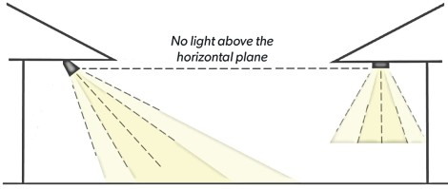  AO1.2  All outside lights are fitted with light motion detection sensors and/or timers to ensure lighting is turned off when not required. | Provide a brief description how your proposal complies with the relevant Acceptable outcome (if applicable) or a detailed analysis how compliance is achieved with the Performance outcome.
PO2  Development minimises the use and intensity (brightness/luminance) of outside lighting required to achieve the light’s purpose to avoid reflection from the ground, buildings, and other surfaces. | AO2  No acceptable outcome provided | Click and provide your representations.
PO3  Development minimises reflective glare that contributes to sky glow. | AO3.1  External building materials, colours, and finishes have low reflectivity.  AO3.2  Impervious areas use coloured (non-reflective) concrete or other pavement materials.  AO3.3  Building design, architectural elements or landscaping treatments block or reduce excessive reflective glare. | Click and provide your representations.
PO4  All interior lighting provided as part of the development avoids direct illumination of the beach, ocean and sky at night. | AO4.1  All windows and glass doors visible from the coast are:-  - tinted with non-reflective tinting, or utilise smart glass technology, to block a minimum of 50% of light to reduce light transmission or spill from indoor lighting (i.e. allows a maximum of 50% of light to pass through); or  - shielded by external screens to reduce light spill from indoor lighting.  AO4.2  All windows are shielded with external fixed louvres, and are to be:-  - solid (i.e. no holes);  - directed downward from the window at a minimum angle of 30°;  - in accordance with the dimensions identified within Figure 8.2.11B (Fixed louvres detail).  Figure 8.2.11B Fixed louvres detail  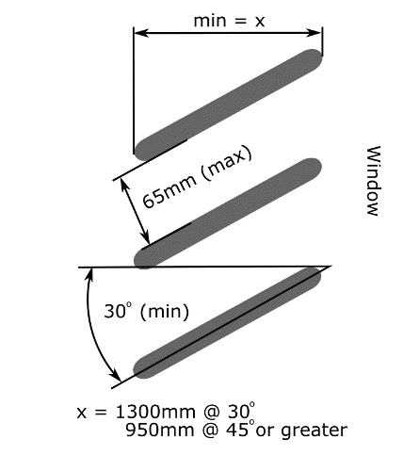 | Click and provide your representations.
Building height and built form
PO5  Development has a building height, built form and density that:-  - is consistent with the maximum building height for the development nominated in the applicable zone code; and  - avoids adverse impacts on sea turtle nesting and sea turtle activity.  Editor’s Note—the Council may require submission of a visual impact assessment and/or artificial light impact assessment and management plan, prepared by a suitably qualified consultant (e.g. landscape architect or environmental scientist) to demonstrate compliance with this performance outcome. | AO5  No acceptable outcome provided. | Click and provide your representations.
Where development is visible to the beach or ocean
PO6  Development provides for landscape buffers that:-  - protect the edges of existing native vegetation or any other areas of environmental significance; and  - screen the development (including associated artificial light) to a level where it is not visible from the beach or ocean. | AO6  Landscape buffers are required to be designed, constructed, and maintained in accordance with the following:-  - plant species selected are appropriate for the location, drainage and soil type, and require minimal ongoing maintenance;  - plant selection includes a range of species to provide variation in form, colour and texture to contribute to the natural appearance of the buffer;  - planting density results in the creation of upper, mid and understorey strata with:-  - large trees planted at 6m centres;  - small trees planted at 2m centres;  - shrubs planted at 1m centres;  - tufting plants, vines and groundcovers are planted at 0.5m to 1m centres; and  - where adjoining the edge of native vegetation or watercourse understorey, shrubs and vines are used to bind the buffer edges against degradation and weed infestation.  Note—planting density is such that is maximises the blocking of light spillage between development and the beach or ocean.  Note—Figure 8.2.11C (Design of landscape buffers) demonstrates the preferred form and structure of landscape buffers.  Figure 8.2.11C Design of landscape buffers  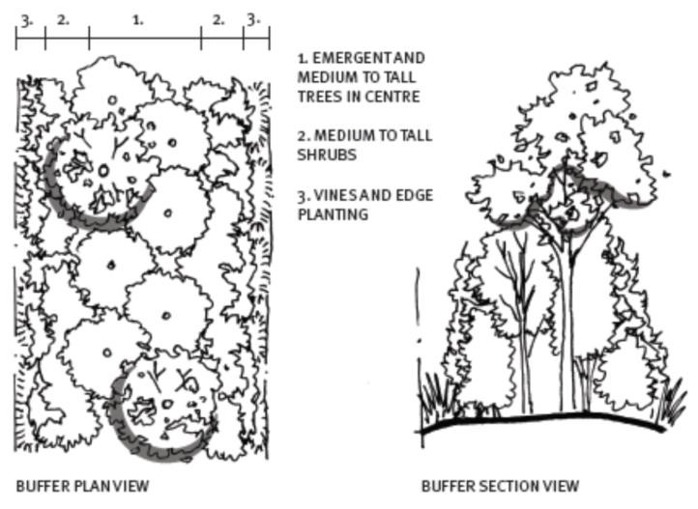 | Click and provide your representations.
PO7  Development involving sport and recreation activities avoids floodlighting. | AO7  No acceptable outcome provided | Click and provide your representations.
PO8  No new beach access points are established unless the beach access is designed to reduce interference on turtle nesting areas, and:-  - is required to enhance public access to the beach; or  - there is no increase in the number of beach access points, with any replaced beach accesses fenced off and revegetated. | AO8  No acceptable outcome provided | Click and provide your representations.
Additional criteria for building and operational work
PO9  Effective measures are implemented during the construction and operation of development to avoid impacts from lighting, noise and vibration on sea turtle activity and sea turtle nesting beaches. | AO9  No acceptable outcome provided | Click and provide your representations.

Editor’s note—Sea turtle sensitive areas are identified on the Coastal Protection Overlay Maps in Schedule 2 (Mapping).

