Local centre zone code

Application
This code applies to development:-

- within the Local centre zone as identified on the zone maps contained in Schedule 2 (Mapping); and

- identified as requiring assessment against the Local centre zone code by the tables of assessment in Part 5 (Tables of assessment).

Purpose and overall outcomes
- The purpose of the Local centre zone code is to provide for a limited range of land uses and activities to meet the local level retail, business and community needs of coastal towns and their surrounding rural catchments and residential neighbourhoods within Bundaberg.

The zone accommodates local shopping and commercial activities, cafes and dining, community services and residential development where it can integrate and enhance the fabric of the activity centre, but is not the predominant use.

Local centres are developed as well-designed, safe and visually attractive centres, predominantly in a low rise building format, where significant off-site impacts are avoided.

Local centres complement and do not undermine the role and function of higher order activity centres.

- The purpose of the Local centre zone code will be achieved through the following overall outcomes:-

  - development provides for a range of business activities that are compatible with the intended role and function of the Local centre zone, but does not include a department store or discount department store, and full-line supermarkets are only established in the zone where there is demonstrated need;

  - development provides for a range of complementary uses in appropriate locations to support community wellbeing and local employment opportunities;

  - development provides for a limited range of residential activities that are ancillary to and support the predominant business functions of the zone, with short-term accommodation provided in appropriate locations to meet the needs of tourists and travellers;

  - development within the Bargara and Burnett Heads town centres:-

- provides for an active and vibrant public realm accommodating a variety of shopping, dining and entertainment activities;
- contributes to an attractive and functional streetscape incorporating high quality urban design and landscaping to retain and build upon the character of these coastal towns; and
- provides an appropriate density of residential development to accommodate an immediate resident population to support these local centres;

  - land uses contributing to employment, education and services in the Bundaberg Region are located in the centre commensurate with its local role and function. However, development does not undermine or compromise the activity centre network by proposing higher order or Iarger scale of uses that are more appropriately located in the principal activity centre, major activity centre or district centres;

  - new regional level State government facilities for justice, education, health, community, administration and employment activities serving the Bundaberg Region are located in the Bundaberg CBD as the principal activity centre rather than in local centres;

  - development has a built form that: -

    - is predominantly low-rise, with a low to medium rise built form in the Bargara and Burnett Heads town centres; and
    - is compatible with the existing and intended scale and character of the streetscape and surrounding area;

- development incorporates a high standard of architecture, urban design and landscaping that creates an attractive and functional “main street” setting or otherwise provides an attractive streetfront address;

- development provides for efficient and effective transport networks that maximise accessibility within and to the centre; and

- development encourages and facilitates the efficient provision and safe operation of physical and social infrastructure.

Specific benchmarks for assessment

Table 6.2.7.3.1 Benchmarks for assessable development
Performance outcomes | Acceptable outcomes | Compliance / Representations
Land use composition and activity centre network
PO1  Development provides for a range of business activities that service the local level convenience needs of residents and surrounding tourism or primary production industries, and offers locally-based employment opportunities.  Note—such business activities include, but are not limited to, food and drink outlets, small-scale offices, shops, small shopping centres and veterinary services. | AO1  No acceptable outcome provided. | Provide a brief description how your proposal complies with the relevant Acceptable outcome (if applicable) or a detailed analysis how compliance is achieved with the Performance outcome.
PO2  Development for business activities is of a scale and intensity that is consistent with the intended role and function of the local activity centre. | AO2  No acceptable outcome provided. | Click and provide your representations.
PO3  Development ensures that:-  - higher order shopping facilities, including department stores and discount department stores, are not established in the zone; and  - major full-line supermarkets are only established in the zone where there is demonstrated need. | AO3  No acceptable outcome provided. | Click and provide your representations.
PO4  Development provides for a range of complementary community activities in appropriate locations to encourage community interaction and support the health, safety and wellbeing of local residents.  Note—such community activities include community uses, emergency services and health care services. | AO4  No acceptable outcome provided. | Click and provide your representations.
PO5  Service industry and utility uses may also be established in the zone where such uses are compatible with the character and amenity of surrounding development. | AO5  No acceptable outcome provided. | Click and provide your representations.
PO6  Development provides for a limited range of residential activities, primarily accommodated in mixed use buildings, where such activities are ancillary to and support the predominant business functions of the zone. | AO6  Development provides for one or more of the following residential activities, accommodated in a mixed use building format:-  - caretaker’s accommodation;  - dual occupancies;  - dwelling units (e.g. shop top housing);  - multiple dwellings; and  - short-term accommodation. | Click and provide your representations.
PO7  Short-term accommodation is established in those parts of the zone located in tourism focus areas and in locations that are highly accessible to tourists or travellers (e.g. Moore Park Beach, Burnett Heads, Bargara and Elliott Heads). | AO7  No acceptable outcome provided. | Click and provide your representations.
Building height, built form and urban design
PO8  Development, other than in the Burnett Heads and Bargara town centres, has a maximum building height of 2 storeys and 10m. | AO8  No acceptable outcome provided. | Click and provide your representations.
PO9  Development in the Bargara town centre has a maximum building height of 5 storeys. | AO9  No acceptable outcome provided. | Click and provide your representations.
PO10  Development in the Burnett Heads town centre has a building height, awnings, and front setbacks in accordance with Figure 6.2.7A (Burnett Heads town centre alternative Building Heights and Setbacks).  Figure 6.2.7A Burnett Heads town centre alternative Building Heights and Setbacks  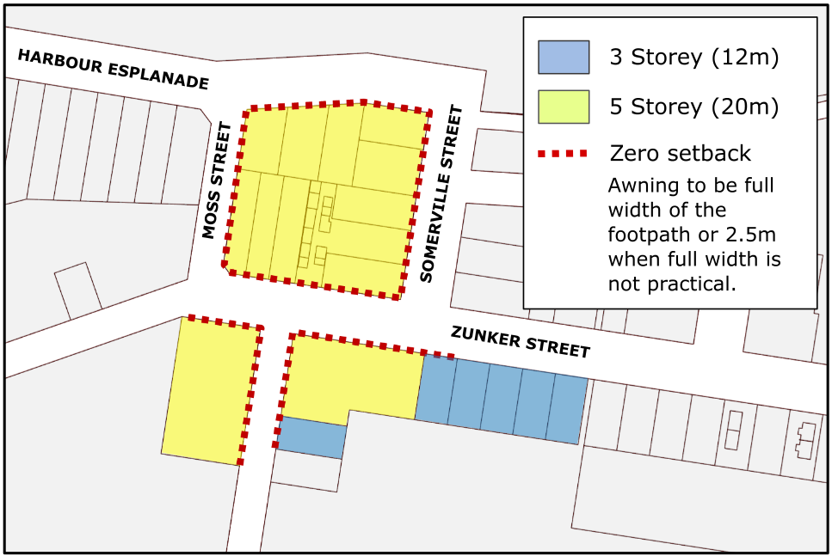 | AO10  No acceptable outcome provided. | Click and provide your representations.
PO11  Development in the Burnett Heads and Bargara town centres: -  - positively contributes to the streetscape and maintains a high level of residential amenity; and  - provides for buildings that are built to the street frontage and designed to promote activity, including wide awnings to provide for footpath dining and all-weather protection for pedestrians.  Note—in assessing whether development maintains or provides a high level of residential amenity, the assessment manager will consider both the potential impacts on the amenity of nearby residents and premises, and the residential amenity for future residents of the proposed development, having regard to (amongst other things):-  - adequate day light and ventilation to habitable rooms, the extent and duration of any overshadowing and other microclimatic impacts;  - privacy and overlooking impacts; and  - building mass and scale as seen from neighbouring premises, and from the street. | AO11  No acceptable outcome provided. | Click and provide your representations.
PO12  The built form and urban design of development incorporates a high standard of architecture, urban design and landscaping that creates attractive and functional buildings, streets and places. | AO12  No acceptable outcome provided. | Click and provide your representations.
PO13  Where existing development in the zone exhibits a traditional “main street” character, new development maintains and reinforces this established character. | AO13  No acceptable outcome provided. | Click and provide your representations.
Transport networks
PO14  Development encourages public transport accessibility and use and also provides for pedestrian, bicycle and vehicular movement networks that maximise connectivity, permeability and ease of movement within and to the centre. | AO14  No acceptable outcome provided. | Click and provide your representations.
Infrastructure and services
PO15  Development is provided with urban services to support the needs of the community, including parks, reticulated water, sewerage, stormwater drainage, sealed roads, pathways, electricity and telecommunication infrastructure. | AO15  No acceptable outcome provided. | Click and provide your representations.
PO16  Development does not adversely impact on the continued operation, viability and maintenance of existing infrastructure or compromise the future provision of planned infrastructure. | AO16  No acceptable outcome provided. | Click and provide your representations.

